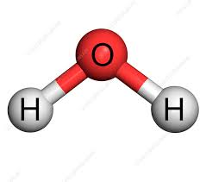  Have you ever wondered why your teacher drew a water molecule like this?      Use the two links to help you answer the questions below  Q1. Draw a dot and cross diagram to show the bonding in a molecule of aluminium chloride (AlCl₃)  Q2. Draw a dot and cross diagram to show the bonding in a molecule of ammonia (NH₃) Q3. What is the shape and the bond angles in a molecule of methane (CH₄)? |   Balancing chemical equations is the stepping stone to using equations to calculate masses in chemistry.  Watch my video if you need extra help  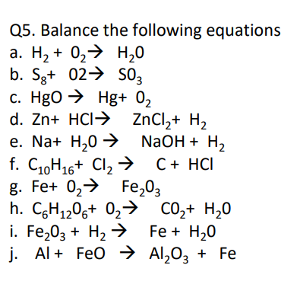    You can use the simulation below to help
  Read the article below and answer the questions at the end |   Explore a few topics that interest you. You could use this as a starting point for the question you will research as part of this transition study.
Think about which part of Chemistry you enjoy most or find most intriguing – what do you want to understand better, or are you curious about?
Turn that interest into a question, for example:
Why does water have such a high melting point compared to other simple covalent molecules and why is ice less dense than water
What caused the hole in the ozone and what did we do to help close it
Use reliable websites, books and articles to find out more about this topic and take notes.
Use your notes to write a response to your question

